**CNG KIT CYLINDER & PARTS MANGEMENT SYSTEM**

**OF**

**ENERGY ZONE**

**GROUP MEMBERS**

**MUHAMMAD UNAIS.17B-017-SE.SEM 1V SE-A**

**SHOAIB AHMED.17B-033-SE.SEM IV SE-A**

**HASSAN AHMED.17B-049-SE.SE A. SEM IV SE-A**

**ALI AKBAR.16B-056-SE. SEM IV SE-A**

**COURSE INSTRUCTOR**

**INSTRUCTOR NAME: USMAN WAHEED**

**TOPIC**

**BLACKBOX TESTING**

**USMAN INSTITUTE OF TECNOLOGY**

Contents

Add Purchase and Service Interface 3

Control Testing 5

1. Textbox (Alphanumeric, Numeric, Alphabetic, Formatted) 5

Contributors 5

2. Dropdown List Box 8

Contributors 8

Purpose 8

Test cases (input based): 8

3. Command Buttons 10

Contributors 10

Purpose 10

Category: 11

Test cases (input based): 11

None 11

Test cases (step based): 11

Guidelines 13

Reference: 13

Interface Testing 14

1. Aesthetic Conditions: 14

Contributors 14

Reference: 16

Contributors 17

Reference: 20

Contributors 20

Contributors 23

Contributors 27

Contributors 29

Contributors 31

7. General Condition 34

Contributors 34

**DEVELOPED DRIVER** 40

**PROPOSED INTERFACE** 40

# Add Purchase and Service Interface

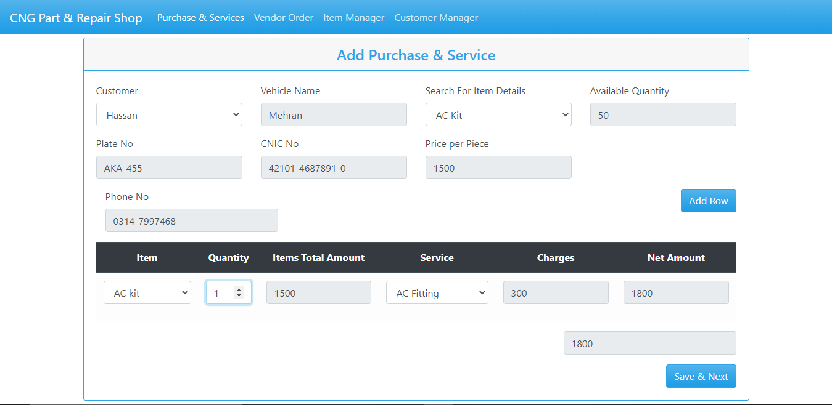

*Figure 1: Add Purchase and Service Interface.*

**List of 3 valid values**

|  |  |  |  |
| --- | --- | --- | --- |
| **Control name** | **Valid value 1** | **Valid value 2** | **Valid value 3** |
| Textbox(Alphabetic) | Hassan | HASSAN | Hassan hussain |
| Textbox(Numeric) | 03460-188917 | 03460-189917 | 03460-900917 |
| Textbox(Alpha Numeric) | AKA-455 | ADL-001 | AAA-056 |
| Dropdown | - | - | - |
| Command button | - | - | - |

# Control Testing

### Textbox (Alphanumeric, Numeric, Alphabetic, Formatted)

### Contributors

MUHAMMAD UNAIS, [unaiszahid123@gmail.com](mailto:unaiszahid123@gmail.com) , Usman Institute of technology

**Purpose**

Textbox is a rectangular box which is placed on the interface for taking an input. It is the most common control found in almost any software programs. Textbox is usually used as enter data in it, On clicking the textbox the cursor flashes indicating the text or data can be entered now.

Text box is used to enter and retrieve data to backend database, or can contain in some case default values.

Text box in add purchase and service are used to store different types of data like name, nic, number plate ,item and other which are shown in the figure 1.

**Example**



Figure 2: Textboxes.

**Category:**

Textbox is Input Control base.

**Test case (input Based)**

1. Does the Textbox proceeds when there is no input?
2. Does the Textbox field input Alphabetic data?
3. Does the Textbox field input Numeric data?
4. Does the Textbox field inputs alphanumeric data?
5. Does the CNIC no accepts if 13 digits not provided?
6. Does No Plate given over limit data?
7. Does field allow copy paste or cut options?
8. Does field have limit 20 characters for name?
9. Does field have limit of 12 characters for vehicle name?
10. Does field have min limit of 3 characters for name?
11. Does field allow point values?
12. Does field accepts comma between values?
13. Does field provide error when wrong input is provided alphabet in place of numeric value?
14. Does Dropdown provide the required data?
15. Does field accepts negative number?

|  |  |  |  |
| --- | --- | --- | --- |
| Test case Name | Input | Output | Valid /Invalid |
| The Textbox proceeds when there is no input |  | Textbox filled red display | Valid |
| The Textbox field input Alphabetic data | HASSAN | Textbox filled green display | Valid |
| the Textbox field input Numeric data | 0332-0578641 | Textbox filled green display | Valid |
| The Textbox field inputs alphanumeric data | AKA-455 | Textbox filled green display | Valid |
| CNIC no accepts if 13 digits not provided | 42301-02111- | Textbox filled red display | Valid |
| No Plate given over limit data | FSS-014 (no more input after 6 ) | Textbox filled green display | Valid |
| Field allow copy paste or cut options | Copy and Paste allow when required data | Textbox filled green display | Valid |
| Field have 20 characters for name | Mustansar Hussain tarrar | Textbox filled green display | Valid |
| Field have 20 characters for name | Mustansar Hussain tarrar Rizvi | Textbox filled red display | Invalid |
| Field have limit of 12 characters for vehicle name | Corolla | Textbox filled green display | Valid |
| Field have min limit of 3 characters for name | Al | Textbox filled red display | Invalid |
| Field allow point values | 15.23 | Textbox filled red display | Invalid |
| Field accepts comma between values | 1621,55 | Textbox filled green display | Valid |
| Field provide error when wrong input is provided alphabet in place of numeric value | Hass167 | Textbox filled red display | Invalid |
| Dropdown provide the required data |  | Textbox filled green display | Valid |
| Field accepts negative number | -15000 | Textbox filled red display | Invalid |

**Strategy:**

In the Figure 1 the Addition of new item or the service interface is provided to the user where it add the new purchase item and the services offered by the shop. In this interface the user must provide the required data when all the textboxes filled green it means all data provide is valid and then it save by pressing the save and next button the fill data is save in the database.

**Test cases (step based)**

None

**Guide lines**

* Does the interface provides all the required information needed for a transition?
* Does textboxes provide the appropriate tittle?
* Does the textbox provide error when inappropriate data is provided?
* Does the alphanumeric input has example to help user?
* Does the name textbox has limit of at least 20 characters?
* Does it save the data when proceed to save and next?
* Does it provide add of item or service at time of invoice if some further parts are added?
* Do invoice show invoice number?
* Does it provide date and time if further necessary?

**References**

“GraphicalUITestingChecklist”,https://www.stickyminds.com/sites/default/files/article/file/2014/Graphical%20UI%20Testing%20Checklist.pdf

**What else not included:**

* Check for RED asterisk for mandatory fields. (as per requirements)
* Enter valid value in mandatory Textbox and save the window. Again come to same window and delete that value and test if it asks for value as it is mandatory
* If value is coming from DB then check if you can edit same. If value is coming from DB then check if the value is correct and populating correctly and should also be possible with mouse. Double Click should select all text in box. Move the Mouse Cursor over all Enterable Text Boxes. Cursor should change from arrow to Insert Bar.

### Dropdown List Box

### Contributors

MUHAMMAD UNAIS, [unaiszahid123@gmail.com](mailto:unaiszahid123@gmail.com) , Usman Institute of Technology.

### Purpose

The purpose of drop-down list box, users make a choice among a list of mutually exclusive values. Users can choose one and only one option. With a standard drop-down list, users are limited to choices in the list. This help to a quick response in the action of the user.

**Example**

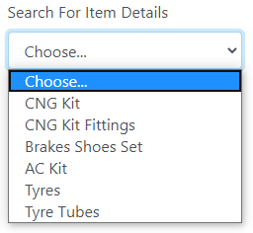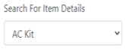

Figure 1 Dropdown list Box

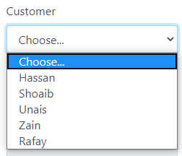

Figure 2 Dropdown list Box

In Figure 2: we have dropdown list box with several option in which we can any option from the given list, such as we have selected car brand.

**Category:**

Selective Controls.

### Test cases (input based):

None

**Test cases (step based)**

* Do click on the arrow of the control and check if list should be displayed?



Figure 3 Customer Name Drop Down List Box

Select any one option from the list



Figure 4 list of appropriate items

**Strategy:**

In figure one select the dropdown arrow to show the appropriate data of the required field if any data is useful select from the list as shown in figure 3.

**Guide lines**

* Do check drop down displayed (as arrow) over control.
* Do check drop down list is appropriate.
* Do check for default value that should be displayed or it should be BLANK.
* Do check if list contains number of values then “Scroll” option should display and it should be working.
* Do check for alignment of list is associated with control.
* Do check for “TEXT” identifier displayed with the control.
* Do check after clicking on arrow image should display as clicked.
* Does that the drop-down has a proper title.
* Does that the default item is getting displayed when the user first visits the page.
* Does that on clicking the down arrow all items are getting listed in its expected order.
* Does the spelling, font and style of the text inside the drop-down.

**References**

[1] on 31st August 2012 / by minu.podipara, et al. “How to Test Drop down Lists on Websites?” Digital Solutions Provider, [www.zyxware.com/articles/4291/how-to-test-drop-down-lists-on-websites](http://www.zyxware.com/articles/4291/how-to-test-drop-down-lists-on-websites).

### Command Buttons

### Contributors

MUHAMMAD UNAIS, [unaiszahid123@gmail.com](mailto:unaiszahid123@gmail.com) , Usman Institute of Technology.

### Purpose

The command buttons are small rectangle on a graphical user interface with a command, such as open, close, OK, or print, With a command button, users initiate an immediate action by clicking on it .It provides the user a simple way to trigger an event like: SAVE button is used to save the values at the backend or the database. The source of this kind of control is the backend and the type or the category of it is clickable (selectable) because there is no need to input any kind of data and they do not provide any kind of output they only trigger an event of your choice

**Example**

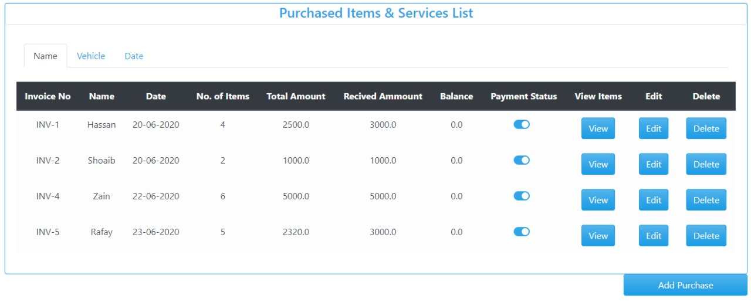

Figure 1 Command Buttons View, Add, Delete and Add Purchase.

**

Figure 2 Command Buttons Add Row and Save and Next.

### Category:

The type is clickable (selectable)

### Test cases (input based):

### None

### Test cases (step based):

1. Do check appropriate TEXT associated with the button or not?

**Steps:**

* 1. Filled customer data interface and then save and next to proceed.

**

* 1. Add Purchase button to proceed to further.

 Figure 3 List of the Add Purchase and Service List.

* 1. Interface of Purchase item and services purchased

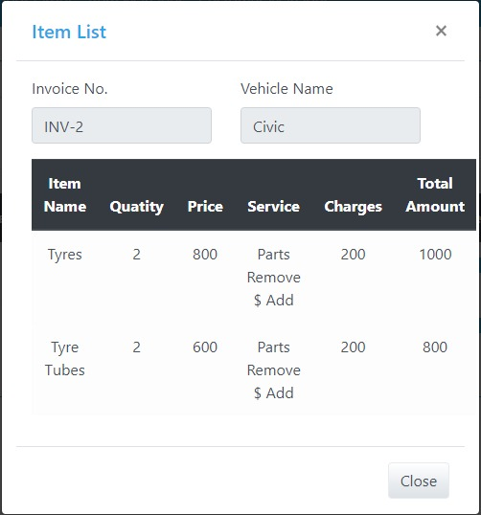

* 1. : Invoice interface of Purchase item and service.

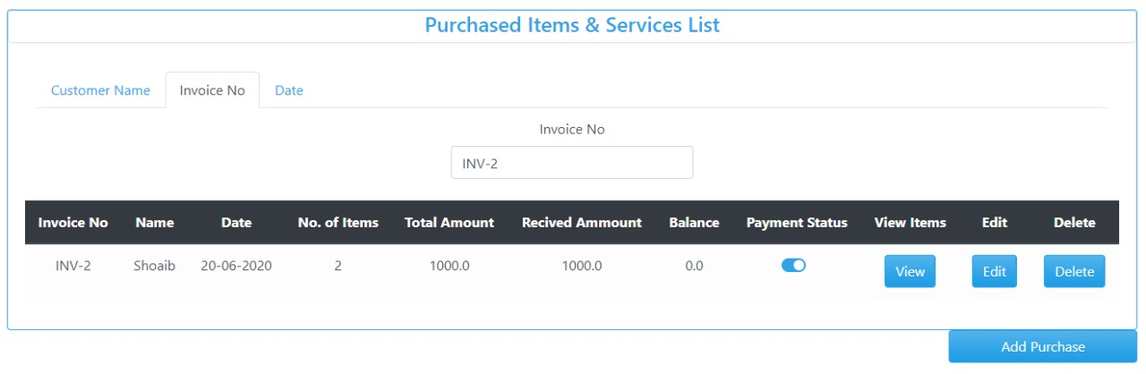 Figure 4 invoice receipt of purchased and service.

**Strategy:**

The Command button help the user to switch between the different interface help them the to view the data, save, retrieve, edit, retrieve data.

### Guidelines

* Do all command buttons are of same dimensions?
* Do check whether expected result is displayed on click?
* Do check the font size of button?
* Do check the font color of button?
* Do check the size of button?
* Do the button proceed further?
* Do all the given button work?
* Do all buttons have appropriate tittle?
* Check the spelling mistake of the label of the button?
* Do you change the button label to the last selection if the most likely command is the last user selection?
* Do you display command button using same text?

### Reference:

1. Atul. “Graphical UI Testing Checklist.” Stickyminds, www.stickyminds.com/sites/default/files/article/file/2014/Graphical%20UI%20Testing%20Checklist.pdf.

# Interface Testing

### Aesthetic Conditions:

### Contributors

MUHAMMAD UNAIS, [unaiszahid123@gmail.com](mailto:unaiszahid123@gmail.com), Usman Institute of Technology.

**Purpose**The purpose is to understand how the user interacts with product and to improve product based on the results. The purpose of this test is improve the design in a typical aesthetic test. The real user provide the ease to use the interface and also help them to achieve the goal.

**Example**

**Customer Add Purchase and Service**

**

Figure 1 Purchased item and Service Interface.

**Category:**

Input Base.

**Test case (input Based)**

* 1. Does the general screen background the correct color is selected?
  2. Do the field prompts the correct color?
  3. Does the field backgrounds the correct color?
  4. Do read-only mode, are the field prompts the correct color?
  5. Do read-only mode, are the field backgrounds the correct color?
  6. Does the screen of all prompts specified in the correct screen font?
  7. Do the text in all fields specified in the correct screen font?
  8. Does the field for all prompts aligned perfectly on the screen?
  9. Does field all the edit boxes aligned perfectly on the screen?
  10. Does all group boxes aligned correctly on the screen?
  11. Does the screen can be resizable?
  12. Does the screen can be minimized?
  13. Do all the field prompts spelt correctly?
  14. Does all character or alpha-numeric fields left justified? This is the default unless otherwise specified.
  15. Does all numeric fields’ right justified? This is the default unless otherwise specified.
  16. Does all the micro help text spelt correctly on this screen?
  17. Does all the error message text spelt correctly on this screen?
  18. Do all user input captured in UPPER case or lower case consistently?
  19. Does the database requires a value (other than null) then this should be defaulted into fields?
  20. The user must either enter an alternative valid value or leave the default value intact?
  21. Do it assure that all windows have a consistent look and feel?
  22. Do it assure that all dialog boxes have a consistent look and feel?

**User Error**

|  |  |  |  |
| --- | --- | --- | --- |
| Controls | Input | Output | Valid /Invalid |
| Text box | Value exceeds | Textbox filled red display | Invalid |
| Text box | Out of range | prompt | Valid |

**Multiple validation rules**

|  |  |  |  |
| --- | --- | --- | --- |
| Controls | Input | Output | Valid /Invalid |
| Text box | Once the value is stored it will automatic appeared as suggestion for second time | Textbox filled green display | Valid |

**Numeric validation rules**

|  |  |  |  |
| --- | --- | --- | --- |
| Controls | Input | Output | Valid /Invalid |
| Text box | Matching the data values | Alert out of range | Valid |

**Invalid entry**

|  |  |  |  |
| --- | --- | --- | --- |
| Controls | Input | Output | Valid /Invalid |
| Text box | Special character | Not a number | Valid |
| Text box | Letter | Not a number | Valid |

*.*

**Test cases (step based)**

None

**Guide lines**

* Do check whether expected result is displayed on click?
* Do check the font size of button?
* Do check the font color of button?
* Do check the size of button?
* Check the spelling mistake of the label of the button?
* Does appropriate TEXT associated with the control, checked?
* Does the label of the control have appropriate naming convention?

### Reference:

1.Atul.“GraphicalUITestingChecklist.”Stickyminds, [www.stickyminds.com/sites/default/files/article/file/2014/Graphical%20UI%20Testing%20Checklist.pdf](http://www.stickyminds.com/sites/default/files/article/file/2014/Graphical%20UI%20Testing%20Checklist.pdf).

1. **Validation Conditions:**

### Contributors

MUHAMMAD UNAIS, [unaiszahid123@gmail.com](mailto:unaiszahid123@gmail.com), Usman Institute of Technology.

**Purpose**

The purpose is to validate the input data that user provide the desire field is valid or invalid which further in data save and other purposes. It is advisable that the individuals responsible for data validation not be directly involved with data collection.

**Example**

**

*Figure 1 Purchased item and Service Interface.*

**Category:**

Input Base.

**Test case (input Based)**

1.   Does a failure of validation on every field cause a sensible user error message?

2.   Does the user required to fix entries which have failed validation tests?

3.   Does any fields have multiple validation rules and if so are all rules being applied?

4.   Do the user enters an invalid value and clicks on the OK button (i.e. does not TAB off the field) is the invalid entry identified and highlighted correctly with an error message?

5.   Does validation consistently applied at screen level unless specifically required at field level?

6.   Do all numeric fields check whether negative numbers can and should be able to be entered?

7.   Does all numeric fields check the minimum and maximum values and also some mid-range values allowable?

8.   Do all character/alphanumeric fields check the field to ensure that there is a character limit specified and that this limit is exactly correct for the specified database size?

9.   Do all mandatory fields require user input?

10. If any of the database columns don't allow null values then the corresponding screen fields must be mandatory. (If any field which initially was mandatory has become optional then check whether null values are allowed in this field.)

1. failure of validation in Name

|  |  |  |  |  |
| --- | --- | --- | --- | --- |
| Controls | Field/control | Input | Output | Valid /Invalid |
| Failure of validation | Name | Mustansar Hussain tarrar Rizvi | Textbox filled red display | Invalid |
| Text box | Name | Mustansar Hussain tarrar | Textbox filled green display | Valid |

1. failure of validation of insert of Dot

|  |  |  |  |  |
| --- | --- | --- | --- | --- |
| Controls | Field/control | Input | Output | Valid /Invalid |
| failure of validation | Dot | Hasssan.Shoaib | Textbox filled red display | Invalid |
| Text box |  | Hassan | Textbox filled green display | Valid |

1. failure of validation of Numeric

|  |  |  |  |  |
| --- | --- | --- | --- | --- |
| Controls | Field/control | Input | Output | Valid /Invalid |
| failure of validation | Numeric | Unais123 | Textbox filled red display | Invalid |
| Text box |  | Unais Zahid | Textbox filled green display | Valid |

1. failure of validation of Special Character

|  |  |  |  |  |
| --- | --- | --- | --- | --- |
| Controls | Field/control | Input | Output | Valid /Invalid |
| Failure of validation | Special Character | Anas@# | Textbox filled red display | Invalid |
| Text box |  | Anas | Textbox filled green display | Valid |

1. failure of validation of Arithmetic Input

|  |  |  |  |  |
| --- | --- | --- | --- | --- |
| Controls | Field/control | Input | Output | Valid /Invalid |
| Failure of validation | Arithmetic Character | 123315 | Textbox filled red display | Invalid |
| Text box |  | Unais | Textbox filled green display | Valid |

1. failure of validation of Alphanumeric

|  |  |  |  |  |
| --- | --- | --- | --- | --- |
| Controls | Field/control | Input | Output | Valid /Invalid |
| Failure of validation | Alpha-Numeric | ASK-01@ | Textbox filled red display | Invalid |
| Text box |  | ASK-201 | Textbox filled green display | Valid |

**Test cases (step based)**

None

**Guide lines**

* Do check whether textbox is filled red color when error?
* Does the test field input limit to 20 characters?
* Does the Require data is saves
* Do it provide all the text boxes with appropriate tittle to make sure that data is filled correct?
* Does alpha numeric has limit?
* Do name enter when dot is placed between them?

### Reference:

[1]Bhadauria, Tarun Kumar. “No Automated Testing: Manual Testing Checklist.” *Selenium Software Testing*, www.seleniumtests.com/2014/05/manual-testing-checklist.html.

1. **Navigation Condition**

### Contributors

MUHAMMAD UNAIS, [unaiszahid123@gmail.com](mailto:unaiszahid123@gmail.com), Usman Institute of Technology.

**Purpose**  
The purpose of navigation to select the option which is given to the users is enable for that interface at a time when to navigate? And where user will go? The primarily purpose to test the navigation is to provide the valid interfaces where user will go through for looking up their information. The background of testing the navigation for the user to allow operations for the legitimate user to manipulates the data from the given information

**Category:**

Selection Base.

**Example**

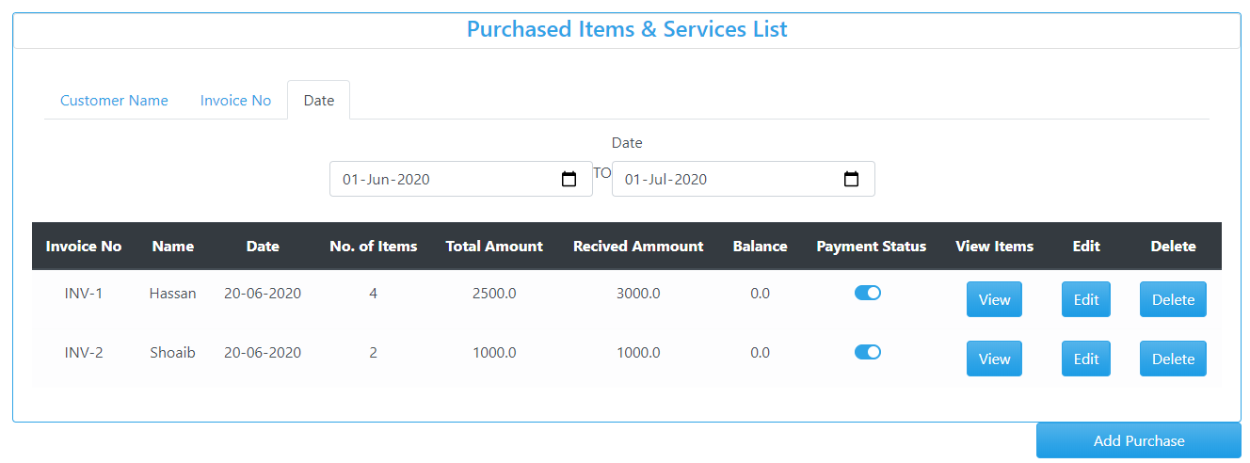

*Figure 1 Purchased item and Service list Interface with sub menu Customer Name, Invoice No, Date(selected).*

**Test case (input Based)**

None

**Test case (step Based)**

1. Does the screen be accessed correctly from the menu?
2. Does the screen be accessed correctly from the toolbar?
3. Does the screen be accessed correctly by double clicking on a list control on the previous screen?
4. Does screens accessible via buttons on this screen be accessed correctly?
5. Do all screens accessible by double clicking on a list control be accessed correctly?
6. Does screen model is the user prevented from accessing other functions when this screen is active and is this correct?
7. Do a number of instances of this screen be opened at the same time and is this correct?
8. Does edit button Validate to edit the data
9. Does delete button Validate to delete the data
10. Screen Select from Menu?

|  |  |  |  |
| --- | --- | --- | --- |
| Controls | Input | Output | Valid /Invalid |
| Screen Select from Menu | E:\Black box testing\2.PNG  Select Purchase & Service. | E:\Black box testing\2.PNGDisplay Required result | Valid |

1. Screen Select from Sub Menu?

|  |  |  |  |
| --- | --- | --- | --- |
| Controls | Input | Output | Valid /Invalid |
| Screen Select from Menu | E:\Black box testing\Search Date.PNG  Select Date from Purchase item & Service List. | E:\Black box testing\Search Date.PNGDisplay Required result | Valid |

**Guidelines**

* Does the selected menu provide the result?
* Do it roll back to the first option?
* Does it provide correct tittle?
* Does menu is easily accusable?
* Do the date is provide?

**References**

[1]Borysowich, Craig. “Radio Buttons Checklist.” *Tech*, it.toolbox.com/blogs/craigborysowich/radio-buttons-checklist-102306.

[2]Harris, Andy, and About the Book Author Andy Harris taught himself programming because it was fun. Today he teachers computer science. “How to Create a Radio Button in an HTML5 Form.” *Dummies*, www.dummies.com/web-design-development/site-development/how-to-create-a-radio-button-in-an-html5-form/.

1. **Usability Conditions:**

### Contributors

MUHAMMAD UNAIS, [unaiszahid123@gmail.com](mailto:unaiszahid123@gmail.com), Usman Institute of Technology.

**Purpose**

The purpose of usability is to provide the user an ease of use is often the biggest factor in the success of any kind of software, web service or mobile app, and navigation tests are great for measuring this in your interface design. They’re simple and to the point—we show users a screen and ask them how they would complete an action. Then we measure how many users manage it, and how quickly

**Example**



*Figure 1 Purchased item and Service list Interface with sub menu Customer Name, Invoice No, Date(selected).*

**Category:**

Selection Base.

**Test case (input Based)**

None

**Test case (step Based)**

1. Does all the dropdowns on this screen sorted correctly? Alphabetic sorting is the default unless otherwise specified.
2. Do all date entry required in the correct format?
3. Does all pushbuttons on the screen been given appropriate Shortcut keys?
4. Do the Shortcut keys work correctly?
5. Does the menu options which apply to your screen have fast keys associated and should they have?
6. Does the Tab Order specified on the screen go in sequence from Top Left to bottom right this is the default unless otherwise specified?
7. Does all read-only fields avoided in the TAB sequence?
8. Does all disabled fields avoided in the TAB sequence?
9. Do the cursor be placed in the micro help text box by clicking on the text box with the mouse?
10. Does the cursor be placed in read-only fields by clicking in the field with the mouse?
11. Do the cursor positioned in the first input field or control when the screen is opened?
12. Do there a default button specified on the screen?
13. Does the default button work correctly?
14. Does an error message occurs does the focus return to the field in error when the user cancels it?
15. Does the user Alt+Tab's to another application does this have any impact on the screen upon return to the application?
16. Do all the fields edit boxes indicate the number of characters they will hold by there length? e.g. a 30 character field should be a lot longer?

* Does edit button work correctly?
* Does delete button work correctly?

1. The dropdowns on this screen sorted correctly? Alphabetic sorting is the default unless otherwise specified?

|  |  |  |  |
| --- | --- | --- | --- |
| Controls | Input | Output | Valid /Invalid |
| Alphabetic sorting in dropdown screen | Select dropdown from | C:\Main Foldf\Downloads\4.PNG | Invalid |

1. Date entry required in the correct format?

|  |  |  |  |
| --- | --- | --- | --- |
| Controls | Input | Output | Valid /Invalid |
| Date entry required in the correct format | E:\Black box testing\Search Date.PNG  Select Date from Purchase item & Service List. | E:\Black box testing\Search Date.PNGDisplay Required result | Valid |

1. All read-only fields avoided in the TAB sequence?

|  |  |  |  |
| --- | --- | --- | --- |
| Controls | Input | Output | Valid /Invalid |
| Read-only fields avoided in the TAB sequence | Apply Tab sequence to read-only | E:\Black box testing\Search Date.PNG | Valid |

1. The cursor be placed in read-only fields by clicking in the field with the mouse?

|  |  |  |  |
| --- | --- | --- | --- |
| Controls | Input | Output | Valid /Invalid |
| Cursor be placed in read-only fields by clicking in the field with the mouse? | Select the field | Read Only | Valid |

1. Does edit button work correctly?
2. Does delete button work correctly

|  |  |  |  |
| --- | --- | --- | --- |
| Controls | Input | Output | Valid /Invalid |
| Edit and Delete data | E:\Black box testing\Search Date.PNG | Data is edited and Deleted. | Valid |

1. There a default button specified on the screen?

|  |  |  |  |
| --- | --- | --- | --- |
| Controls | Input | Output | Valid /Invalid |
| Default Button | No Default Button | None | Invalid |

1. The user Alt+Tab's to another application does this have any impact on the screen upon return to the application

|  |  |  |  |
| --- | --- | --- | --- |
| Controls | Input | Output | Valid /Invalid |
| Alt+Tab's | .  Press Alt+Tab's | No Impact Work Fine. | Valid |

**Guidelines**

* Does the selected dropdown provide the result?
* Do it roll back to the first option?
* Does it provide correct tittle?
* Does it provide correct spell and Grammar?
* Does a text no more than three words in length with all significant first letters capitalized? The use of text is recommended over graphics, it provides a more consistent interface with standard applications?

**REFERNCES:**

[1]

[“GUI Testing Tutorial: User Interface (UI) TestCases with Examples.”](http://\“GUI Testing Tutorial: User Interface (UI) TestCases with Examples.\” Guru99, www.guru99.com/gui-testing.html.) *[Guru99](http://\“GUI Testing Tutorial: User Interface (UI) TestCases with Examples.\” Guru99, www.guru99.com/gui-testing.html.)*[, www.guru99.com/gui-testing.html.](http://\“GUI Testing Tutorial: User Interface (UI) TestCases with Examples.\” Guru99, www.guru99.com/gui-testing.html.)

1. **Data Integrity Conditions**

### Contributors

MUHAMMAD UNAIS, [unaiszahid123@gmail.com](mailto:unaiszahid123@gmail.com), Usman Institute of Technology.

**Purpose**

The purpose of data integrity is that data integrity refers to the maintenance and assurance of the accuracy and consistency of data. It is the characteristic of information to maintain unaltered and intact between transfer, storage, and usage.

**Test cases (step based)**

1. Do check whether or NOT a blank value or default value can be retrieved from the database?
2. Does it validate each value if it is successfully saved to the database?
3. Do it ensuring the data compatibility against old hardware or old versions of operating systems?
4. Does it verifying the data in data tables can be modified and deleted?
5. Does running data tests for all data files, including clip art, tutorials, and templates?
6. Does it verify that you can create, modify, and delete any data in tables?
7. Does it verify that sets of radio buttons represent fixed sets of values?
8. Does it verify that a blank value can be retrieved from the database?
9. Does it verify that, when a particular set of data is saved to the database, each value gets saved fully, and the truncation of strings and rounding of numeric values do not occur?
10. Do it verify that the default values are saved in the database, if the user input is not specified?
11. Do it verify compatibility with old data, old hardware, versions of operating systems, and interfaces with other software?
12. Does it provide data integrity and Data should be stored in single or multiple tables based on the design?
13. Does Data should be rolled back in case of failed transactions?
14. Does Input field leading and trailing spaces should be truncated before committing data to the database?
15. Does Null values should not be allowed for the Primary key column?
16. Check whether or NOT a blank value or default value can be retrieved from the database?

|  |  |  |  |
| --- | --- | --- | --- |
| Controls | Input | Output | Valid /Invalid |
| Blank Space Check | E:\Black box testing\Search Customer Name.PNG | E:\Black box testing\Search Customer Name.PNG | Valid |

1. verify that you can create, modify, and delete any data in tables

|  |  |  |  |
| --- | --- | --- | --- |
| Controls | Input | Output | Valid /Invalid |
| Verify Edit and Delete data | E:\Black box testing\Search Date.PNG | Data is edited and Deleted. | Valid |

1. Null values should not be allowed for the Primary key column?

|  |  |  |  |
| --- | --- | --- | --- |
| Controls | Input | Output | Valid /Invalid |
| Null Value |  | Textbox filled red display | Valid |

**Guidelines**

* Does the selected data provide the correct result?
* Does the user data is integrated?
* Does it allow the user to enter the blank data?
* Does the retrieve data same as save data?
* Does the data can retrieve correct after shutdown?
* Do it save as Upper Letter of name?
* Does the Save and Next Command button proceed the further data into database?
* Do all field provide the data and data like N.I.C is more secure?

**References**

[1]

[Amrutha, et al. “180+ Sample Test Cases for Testing Web and Desktop Applications - Comprehensive Software Testing Checklist.”](http:// Amrutha, et al. \“180+ Sample Test Cases for Testing Web and Desktop Applications - Comprehensive Software Testing Checklist.\” Software Testing Help, 30 June 2020, www.softwaretestinghelp.com/sample-test-cases-testing-web-desktop-applications/.[2]\“Data Integrity Testing.\” Tutorialspoint, www.tutorialspoint.com/software_testing_dictionary/data_and_database_integrity_testing.htm.t) *[Software Testing Help](http:// Amrutha, et al. \“180+ Sample Test Cases for Testing Web and Desktop Applications - Comprehensive Software Testing Checklist.\” Software Testing Help, 30 June 2020, www.softwaretestinghelp.com/sample-test-cases-testing-web-desktop-applications/.[2]\“Data Integrity Testing.\” Tutorialspoint, www.tutorialspoint.com/software_testing_dictionary/data_and_database_integrity_testing.htm.t)*[, 30 June 2020, www.softwaretestinghelp.com/sample-test-cases-testing-web-desktop-applications/.](http:// Amrutha, et al. \“180+ Sample Test Cases for Testing Web and Desktop Applications - Comprehensive Software Testing Checklist.\” Software Testing Help, 30 June 2020, www.softwaretestinghelp.com/sample-test-cases-testing-web-desktop-applications/.[2]\“Data Integrity Testing.\” Tutorialspoint, www.tutorialspoint.com/software_testing_dictionary/data_and_database_integrity_testing.htm.t)

[[2]“Data Integrity Testing.”](http:// Amrutha, et al. \“180+ Sample Test Cases for Testing Web and Desktop Applications - Comprehensive Software Testing Checklist.\” Software Testing Help, 30 June 2020, www.softwaretestinghelp.com/sample-test-cases-testing-web-desktop-applications/.[2]\“Data Integrity Testing.\” Tutorialspoint, www.tutorialspoint.com/software_testing_dictionary/data_and_database_integrity_testing.htm.t) *[Tutorialspoint](http:// Amrutha, et al. \“180+ Sample Test Cases for Testing Web and Desktop Applications - Comprehensive Software Testing Checklist.\” Software Testing Help, 30 June 2020, www.softwaretestinghelp.com/sample-test-cases-testing-web-desktop-applications/.[2]\“Data Integrity Testing.\” Tutorialspoint, www.tutorialspoint.com/software_testing_dictionary/data_and_database_integrity_testing.htm.t)*[, www.tutorialspoint.com/software_testing_dictionary/data_and_database_integrity_testing.htm.](http:// Amrutha, et al. \“180+ Sample Test Cases for Testing Web and Desktop Applications - Comprehensive Software Testing Checklist.\” Software Testing Help, 30 June 2020, www.softwaretestinghelp.com/sample-test-cases-testing-web-desktop-applications/.[2]\“Data Integrity Testing.\” Tutorialspoint, www.tutorialspoint.com/software_testing_dictionary/data_and_database_integrity_testing.htm.t)

[3] “Database Testing Checklist:” *ProfessionalQA.com*, www.professionalqa.com/database-testing-checklist.

1. **Feedback**

### Contributors

MUHAMMAD UNAIS, [unaiszahid123@gmail.com](mailto:unaiszahid123@gmail.com), Usman Institute of Technology.

**Purpose**

The purpose is to provide a person must have to fill in a column a required field entry, system should accept valid entry, when you have entered whole information of customer you will choose the brand, if you have committed a fault you must edit the entry or delete the entry and help others to provide more useful service.

**Category:**

Input Base.

**Test case (input Based)**

1. Does a person fill anything its mandatory fields should be entered?
2. Does it should be validate that a system accept valid entry?
3. Does the Data should be rolled back in case of failed transactions?
4. Does it pop a message if user input invalid data multiple times?
5. Does it should must provide option for edit data if fault occurs?
6. Does it ensure that an error message is displayed on submitting the form by leaving the mandatory fields empty and expected error messages for the above example is
7. "Your name field is required."
8. "Your Vehicle name field is required."
9. "Brand field is required."
10. "CNIC field is required."
11. "Plate Number field is required."
12. Name field:
13. Does it ensure that the system accepts valid name. If the field is customized, then test accordingly.14
14. Do it ensure that the system rejects the invalid name (input:*##456456@#).
15. Do it ensure that the system accepts valid vehicle. For example; Vehicle: Civic should be accepted?
16. Does it ensure that the system rejects invalid vehicle. For example; inputs "@Civic" should not be accepted?
17. Does it ensure that the system accepts the valid brand and usually consist of alphabets will be accepted. If there is any other specifications like character limits etc., check that as well?
18. Does it ensure that the system accepts valid Plate number and usually all alphanumeric entries will be accepted and If there is any other specifications like character limits etc., check that as well?
19. Does it ensure that the spelling and position of the button is correct?
20. Does it ensure that the button is clickable?
21. Does it ensure that on submitting a valid form, the value get saved and administrator receives the same data?
22. Does it ensure that the spelling and position of the button is correct?
23. Does it ensure that the button is clickable?
24. Does it ensure that on delete an entry should be updated in the system?
25. Does a person fill anything its mandatory fields should be entered

|  |  |  |  |
| --- | --- | --- | --- |
| Controls | Input | Output | Valid /Invalid |
| Fill mandatory fields | E:\Black box testing\2.PNG | Textboxes filled red if blank fields are left | Valid |

**Test case (step Based)**

None

**Guide lines**

For getting feedback we must have to do something, and then the response from the other side or system or person on that action which we do.

2 .Is the user required to fix entries which have failed feedback tests?

When entries are failed we must have to go through by taking a survey

**References**

[1] freeCodeCamp.org. “User Interface Test Automation.” *FreeCodeCamp.org*, FreeCodeCamp.org, 20 Oct. 2017, www.freecodecamp.org/news/user-interface-test-automation-3da36b132077/.

1. **Modes**

### Contributors

MUHAMMAD UNAIS, [unaiszahid123@gmail.com](mailto:unaiszahid123@gmail.com), Usman Institute of Technology.

**Purpose**

The purpose of modes condition is to detect and then verify any data values at the required system. This allow user to editable read only modes and check that the read-only mode is valid.

**Category:**

Input Base.

**Test cases (input based)**

None

**Test cases (step based)**

1. Does the screen and field colors adjusted correctly for read-only mode?
2. Do a read-only mode be provided for this screen?
3. Does all fields and controls disabled in read-only mode?
4. Does the screen be accessed from the previous screen/menu/toolbar in read-only mode?
5. Does all screens available from this screen be accessed in read-only mode?
6. Does it check that no validation is performed in read-only mode?
7. Do it confirm that software Logo ought not to be blurred and title of the software ought not to be incorrectly spelled?
8. Does check the right template sizes are shown in a good manner?
9. Does it check for error messages, for example, « invalid entry, Please, enter valid data» in case of incorrect entry operation
10. The screen and field colors adjusted correctly for read-only mode

|  |  |  |  |
| --- | --- | --- | --- |
| Controls | Input | Output | Valid /Invalid |
| The screen and field colors adjusted correctly for read-only mode | Color are read only | None | Valid |

1. Check for error messages, for example, « invalid entry, Please, enter valid data» in case of incorrect entry operation

|  |  |  |  |
| --- | --- | --- | --- |
| Controls | Input | Output | Valid /Invalid |
| Error Message | Invalid Input | Textbox filled red display | Valid |

3. Read-only mode be provided for this screen

|  |  |  |  |
| --- | --- | --- | --- |
| Controls | Input | Output | Valid /Invalid |
| Read-Only for screen | C:\Main Foldf\Downloads\WhatsApp Image 2020-07-04 at 12.10.09 PM.jpeg | C:\Main Foldf\Downloads\WhatsApp Image 2020-07-04 at 12.10.09 PM.jpeg | Valid |

1. Check the right template sizes are shown in a good manner?

|  |  |  |  |
| --- | --- | --- | --- |
| Controls | Input | Output | Valid /Invalid |
| Checking Template Size | Date | E:\Black box testing\Search Date.PNG | Valid |

**Guide line**

* Does it check the correctness of the app?
* Do it make sure the required fields are not displayed on the screen as optional?
* Does it ensure the software goes into the background in the case of an deleting record
* Does it ensure that the software cannot shuts if the networks make disconnected
* Do it make sure the application automatic startup is correct?
* Does it check for error messages, for example, « invalid entry lease, enter valid data» in case of incorrect entry operation?

**2. Is the user required to fix entries which have failed validation tests?**

NO

**References**

[1]

[Kaur, Hamraj, et al. “Mobile App Testing Tutorials (A Complete Guide with 30+ Tutorials).”](http:// Kaur, Hamraj, et al. \“Mobile App Testing Tutorials (A Complete Guide with 30+ Tutorials).\” Software Testing Help, 30 June 2020, www.softwaretestinghelp.com/beginners-guide-to-mobile-application-testing/.https://www.testbytes.net/blog/test-scenario-GUI-interface/) *[Software Testing Help](http:// Kaur, Hamraj, et al. \“Mobile App Testing Tutorials (A Complete Guide with 30+ Tutorials).\” Software Testing Help, 30 June 2020, www.softwaretestinghelp.com/beginners-guide-to-mobile-application-testing/.https://www.testbytes.net/blog/test-scenario-GUI-interface/)*[, 30 June 2020, www.softwaretestinghelp.com/beginners-guide-to-mobile-application-testing/.](http:// Kaur, Hamraj, et al. \“Mobile App Testing Tutorials (A Complete Guide with 30+ Tutorials).\” Software Testing Help, 30 June 2020, www.softwaretestinghelp.com/beginners-guide-to-mobile-application-testing/.https://www.testbytes.net/blog/test-scenario-GUI-interface/)

[2]“Software Testing and QA Consulting Company.” *Testbytes*, 26 June 2019, www.testbytes.net/.

### General Condition

### Contributors

MUHAMMAD UNAIS, [unaiszahid123@gmail.com](mailto:unaiszahid123@gmail.com), Usman Institute of Technology.

**Purpose**

A general condition agreement is a set of regulations which users must agree to follow in order to use a services of mobiles and webs. It is basically to inform users:

* The guidelines of using your website or mobile app, what happens if users are abusing your website or mobile app. that you are the owner of such content
* The content you own is protected by international copyright laws. that abusive accounts will be terminated and banned from using the service.
* The owner can’t be held responsible for any errors in the content presented, or for the information provided being accurate, complete, or suitable for any purpose

**Checklist**

1.   Does it assure the existence of the "Help" menu?

2.   Does it assure that the proper commands and options are in each menu.

3.   Does it assure that all buttons on all tool bars have a corresponding key commands?

1. Does it assure that each menu command has an alternative (hot-key) key sequence which will invoke it where appropriate?

5.   Does the drop down list boxes, ensure that the names are not abbreviations / cut short?

6.   Does the drop down list boxes, assure that the list and each entry in the list can be accessed via appropriate key / hot key combinations?

7.   Does it ensure that duplicate hot keys do not exist on each screen

8.  Does it ensure the proper usage of the escape key (which is to undo any changes that have been made) and generates a caution message "Changes will be lost - Continue yes/no"

9.   Does it assure that the cancel button functions the same as the escape key?

10. Does it assure that the Cancel button operates as a Close button when changes have be made that cannot be undone?

11. Does it assure that only command buttons which are used by a particular window, or in a particular dialog box, are present - I.e. make sure they don't work on the screen behind the current screen?

12. Does it assure a command button is used sometimes and not at other times, assure that it is grayed out when it should not be used?

13. Does it assure that OK and Cancel buttons are grouped separately from other command buttons?

14. Does it assure that command button names are not abbreviations.

15. Does it assure that all field labels/names are not technical labels, but rather are names meaningful to system users?

16. Does it assure that command buttons are all of similar size and shape, and same font & font size?

17. Does it assure that each command button can be accessed via a hot key combination?

18. Does it assure that command buttons in the same window/dialog box do not have duplicate hot keys?

19. Does it assure that each window/dialog box has a clearly marked default value (command button, or other object) which is invoked when the Enter key is pressed - and NOT the Cancel or Close button?

20. Does it assure that focus is set to an object/button which makes sense according to the function of the window/dialog box?

1. Does it assure that all option buttons (and radio buttons) names are not abbreviations?

22. Does it assure that option button names are not technical labels, but rather are names meaningful to system users?

23. Does hot keys are used to access option buttons, assure that duplicate hot keys do not exist in the same window/dialog box?

24. Does it assure that option box names are not abbreviations?

25. Does it assure that option boxes, option buttons, and command buttons are logically grouped together in clearly demarcated areas "Group Box"?

26. Does it assure that the Tab key sequence which traverses the screens does so in a logical way?

27. Does it assure consistency of mouse actions across windows?

28. Does it assure that the color red is not used to highlight active objects (many individuals are red-green color blind).

29. Does it assure that the user will have control of the desktop with respect to general color and highlighting (the application should not dictate the desktop background characteristics).

30. Does it assure that the screen/window does not have a cluttered appearance?

31. Does Ctrl + F6 opens next tab within tabbed window?

32. Does Shift + Ctrl + F6 opens previous tab within tabbed window?

33. Does Tabbing will open next tab within tabbed window if on last field of current tab?

34. Does Tabbing will go onto the 'Continue' button if on last field of last tab within tabbed window?

35. Does Tabbing will go onto the next editable field in the window?

36. Does Banner style & size & display exact same as existing windows?

37. Do if we press 8 or less options in a list box, display all options on open of list box - should be no need to scroll?

38. Does errors on continue will cause user to be returned to the tab and the focus should be on the field causing the error. (I.e. the tab is opened, highlighting the field with the error on it)

39. Do pressing continue while on the first tab of a tabbed window (assuming all fields filled correctly) will not open all the tabs?

1. Does on open of tab focus will be on first editable field?

41. Does all fonts to be the same?

42. Does press Alt+F4 will close the tabbed window and return you to main screen or previous screen (as appropriate), generating "changes will be lost" message if necessary?

43. Does micro help text for every enabled field & button?

44. Does it ensure all fields are disabled in read-only mode?

45. Does progress messages on load of tabbed screens?

46. Does the return operates continue?

1. Does the retrieve on load of tabbed window fails window should not open?
   1. Date entry required in the correct format?

|  |  |  |  |
| --- | --- | --- | --- |
| Controls | Input | Output | Valid /Invalid |
| Date entry required in the correct format | E:\Black box testing\Search Date.PNG  Select Date from Purchase item & Service List. | E:\Black box testing\Search Date.PNGDisplay Required result | Valid |

* 1. All read-only fields avoided in the TAB sequence?

|  |  |  |  |
| --- | --- | --- | --- |
| Controls | Input | Output | Valid /Invalid |
| Read-only fields avoided in the TAB sequence | Apply Tab sequence to read-only | E:\Black box testing\Search Date.PNG | Valid |

* 1. The cursor be placed in read-only fields by clicking in the field with the mouse?

|  |  |  |  |
| --- | --- | --- | --- |
| Controls | Input | Output | Valid /Invalid |
| Cursor be placed in read-only fields by clicking in the field with the mouse? | Select the field | Read Only | Valid |

* 1. Does edit button work correctly?
  2. Does delete button work correctly?

|  |  |  |  |
| --- | --- | --- | --- |
| Controls | Input | Output | Valid /Invalid |
| Edit and Delete data | E:\Black box testing\Search Date.PNG | Data is edited and Deleted. | Valid |

* 1. There a default button specified on the screen?

|  |  |  |  |
| --- | --- | --- | --- |
| Controls | Input | Output | Valid /Invalid |
| Default Button | No Default Button | None | Invalid |

* 1. All fonts to be the same?

|  |  |  |  |
| --- | --- | --- | --- |
| Controls | Input | Output | Valid /Invalid |
| Font Size | E:\Black box testing\Search Date.PNG | None | Valid |

* 1. Read-only mode be provided for this screen

|  |  |  |  |
| --- | --- | --- | --- |
| Controls | Input | Output | Valid /Invalid |
| Read-Only for screen | C:\Main Foldf\Downloads\WhatsApp Image 2020-07-04 at 12.10.09 PM.jpeg | C:\Main Foldf\Downloads\WhatsApp Image 2020-07-04 at 12.10.09 PM.jpeg | Valid |

**Guidelines**

Make changes in software only by us

Don’t spoil the rights

**Reference**

“Trustpilot Legal - Terms & Conditions.” *Trustpilot*, legal.trustpilot.com/for-reviewers/end-user-terms-and-conditions.

**DEVELOPED DRIVER:**

**PROPOSED INTERFACE:**